**E-COMMERCE WEBSITE USING HTML,CSS & JAVASCRIPT**

**Abstract:**

Electronic Commerce is process of doing business through computer networks. A person sitting on his chair in front of a computer can access all the facilities of the Internet to buy or sell the products. Unlike traditional commerce that is carried out physically with effort of a person to go & get products, ecommerce has made it easier for human to reduce physical work and to save time. E-Commerce which was started in early 1990’s has taken a great leap in the world of computers, but

the fact that has hindered the growth of e-commerce is security. Security is the challenge facing e-commerce today & there is still a lot of advancement made in the field of security. The main advantage of e-commerce over traditional commerce is the user can browse online shops, compare prices and order merchandise sitting at home on their PC.

For increasing the use of e-commerce in developing countries the B2B e-commerce is implemented for improving access to global markets for firms in developing countries. For a developing country advancement in the field of e-commerce is essential. The research strategy shows the importance of the e-commerce in developing countries for business applications.

**Problem Statement:**

There are a lot of websites on internet whereby it offers a variety of product and services for consumer can find and buy through online such as shoe, apparel, sun glasses and more Moreover, the online also provides some of the services which is paying bill online, booking a transport ticket and more. In this research, we are looking the problem addressed in this research which is the view of online shopping by consumer.

However, there are several reason hinder in the consumer are involved in online shopping because some of the consumer are not willing to take part in online purchased due to the valid reason because there are worried about the quality of the product in online are not durable, moreover, there are not confident.

**Methodology:**

It is a responsive E-Commerce where user can buy products. Since it is responsive it can be used in any screen-size. Currently only frontend is developed.

**Architecture:**

E-commerce is based on the client-server architecture. A client can be an application, which uses a Graphical User Interface (GUI) that sends request to a server for certain services. The server is the provider of the services requested by the client.

In E-commerce, a client refers to a customer who requests for certain services and the server refers to the business application through which the services are provided. The business application that provides services is deployed on a Web' server. The E - Commerce Web server is a computer program that provides services to "other computer programs and serves requested Hyper Text Mark-up Language (HTML) pages or files. In client-server architecture, a machine can be both a client as well as a server.

There are two types of client server architecture that E-commerce follows: two-tier and three-tier.

E- Commerce System Architecture: Two-tier architecture:

In two-tier client-server architecture the user interface runs on the client and the database is stored on the server. The business application logic can either run on the client or the server. The user application logic can either run on the client or the server. It allows the client processes to run separately from the server processes on different computers.

**Software and Hardware Used:**

**Software**:

Programming language: HTML, CSS, JAVASCRIPT.

**Hardware**:

Simulated on Laptop (i5 8th generation, 8gb RAM)

**Technical Description:**

Initially we design a basic layout using HTML &CSS. After that we convert it into responsive site using JAVASCRIPT.

**Source Code:**

Provided in the zip file containing all the project files.

**Process Diagram:**

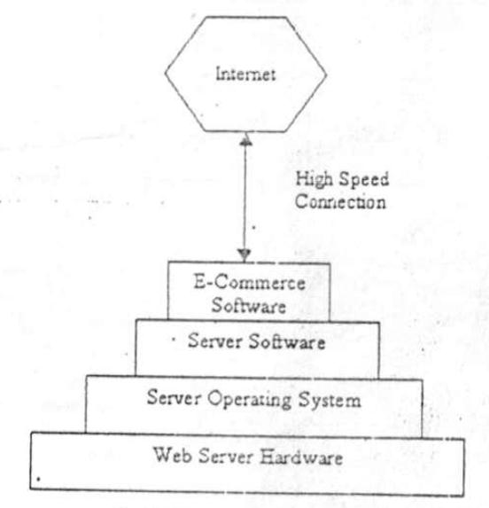

**Results:**

The below two pictures correspond to the results obtained from the trained model by passing images without and with mask respectively.

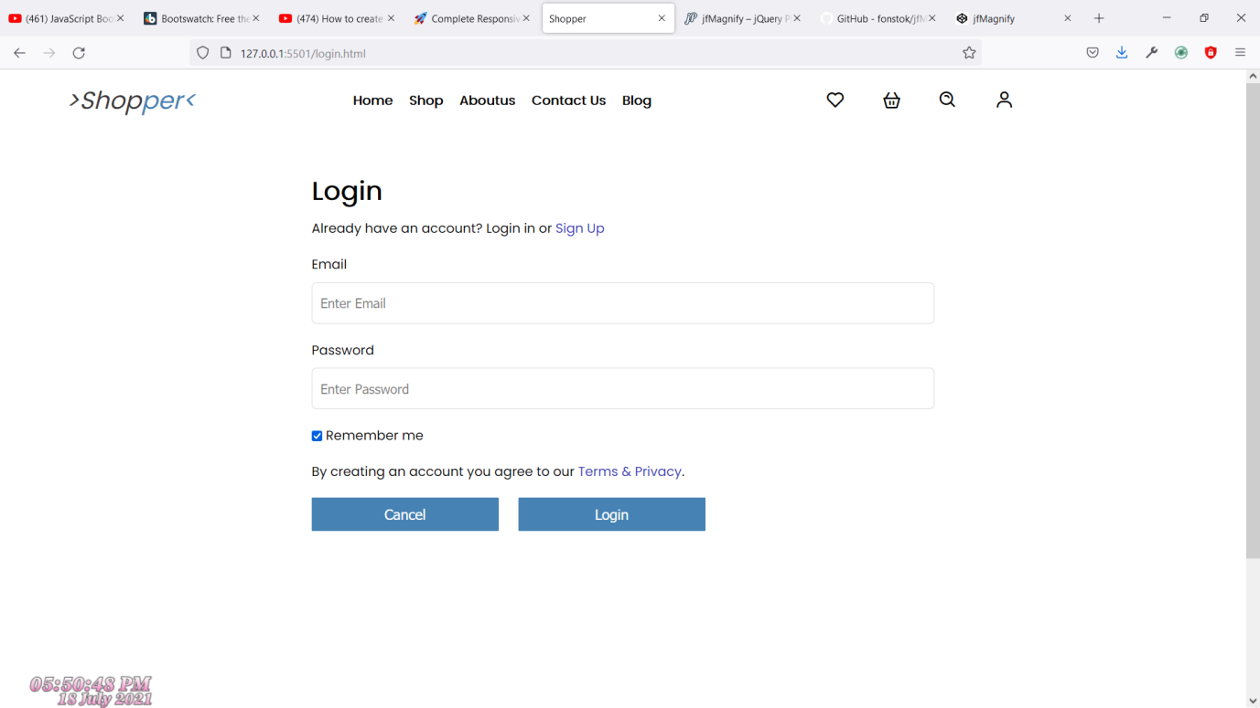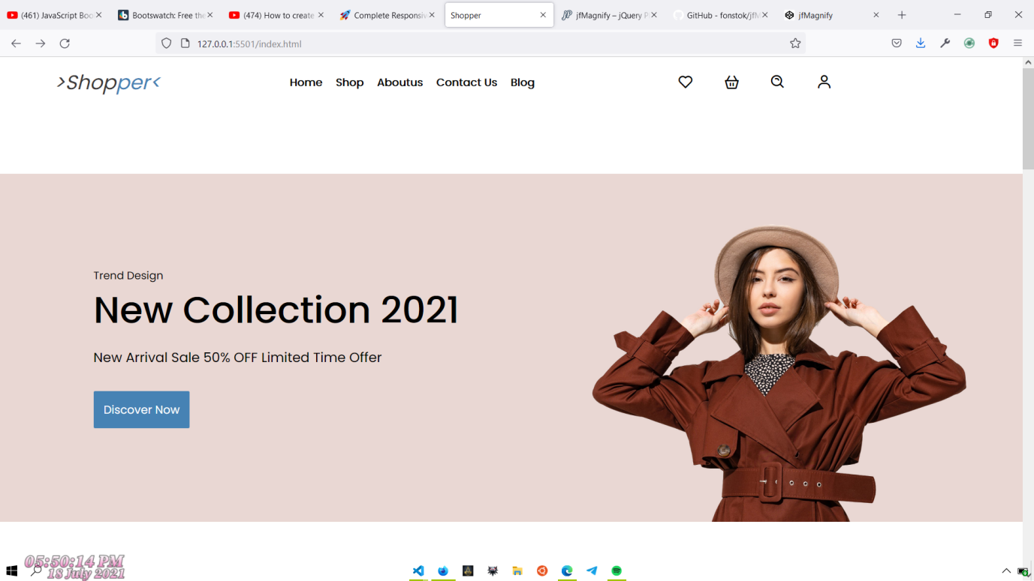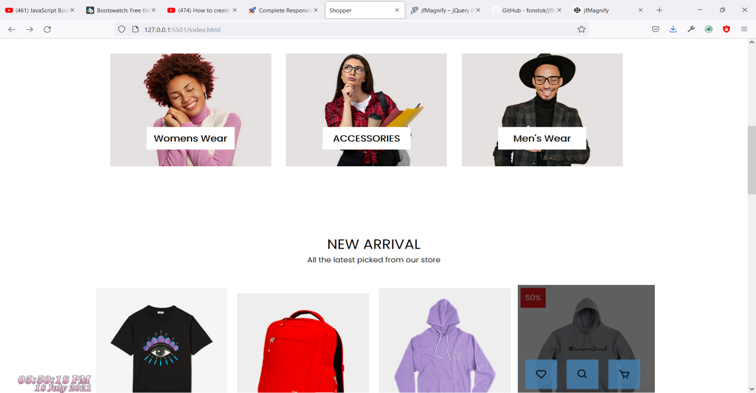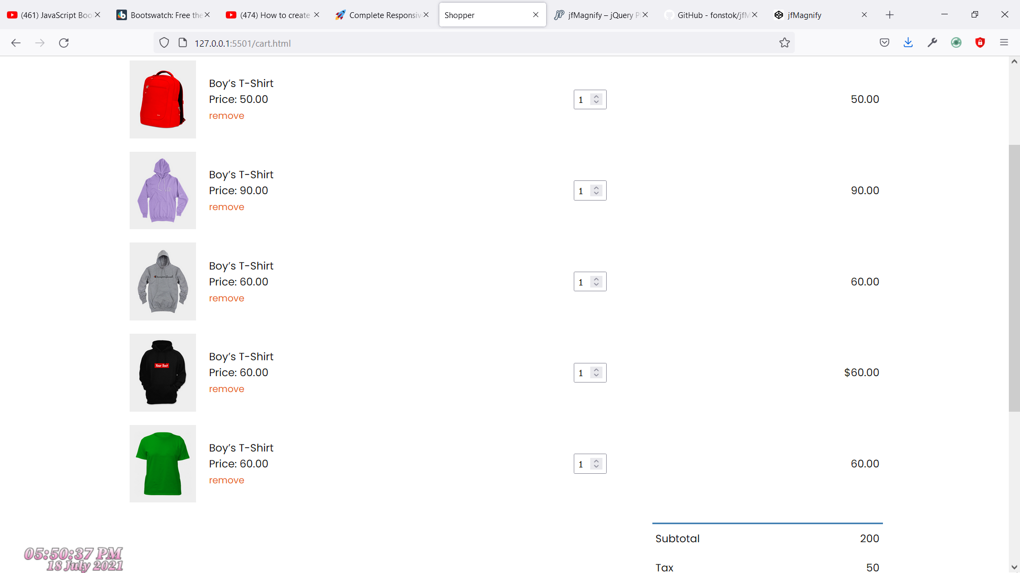

**By:**

198W1A0599

198W1A05A5

198W1A05C8

198W1A05B9

198W1A05B7

**CSE - 2**